---create a store procedure

EXEC sp_GetEmployeesByDepartment @DepartmentID = 3;

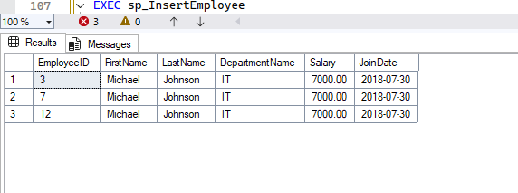

CREATE OR ALTER PROCEDURE sp_InsertEmployee

@FirstName VARCHAR(50),

@LastName VARCHAR(50),

@DepartmentID INT,

@Salary DECIMAL(10,2),

@JoinDate DATE

AS

BEGIN

INSERT INTO Employees (FirstName, LastName, DepartmentID, Salary, JoinDate)

VALUES (@FirstName, @LastName, @DepartmentID, @Salary, @JoinDate);

END;

GO

EXEC sp_InsertEmployee

@FirstName = 'Alice',

@LastName = 'Brown',

@DepartmentID = 1,

@Salary = 5200.00,

@JoinDate = '2022-08-10';

SELECT * FROM Employees;

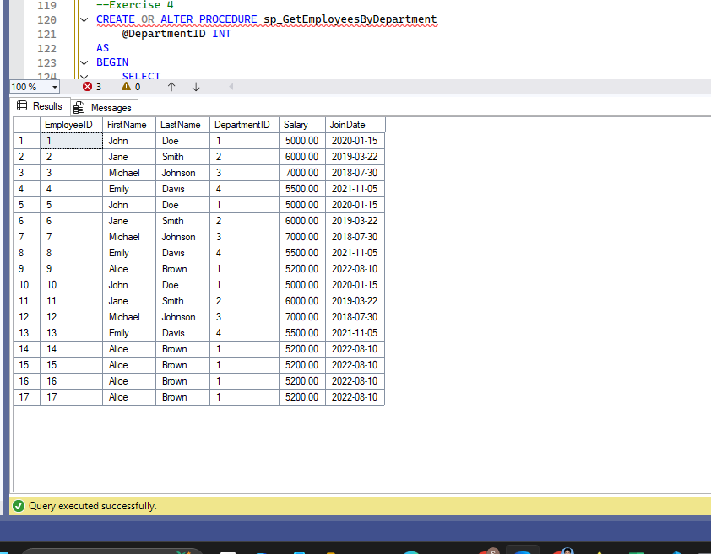

--Exercise 4

CREATE OR ALTER PROCEDURE sp_GetEmployeesByDepartment

@DepartmentID INT

AS

BEGIN

SELECT

EmployeeID,

FirstName,

LastName,

Salary,

JoinDate

FROM Employees

WHERE DepartmentID = @DepartmentID;

END;

GO

EXEC sp_GetEmployeesByDepartment @DepartmentID = 1;

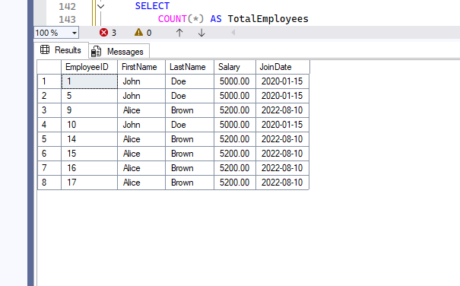

--Exercise 5

CREATE OR ALTER PROCEDURE sp_CountEmployeesInDepartment

@DepartmentID INT

AS

BEGIN

SELECT

COUNT(*) AS TotalEmployees

FROM Employees

WHERE DepartmentID = @DepartmentID;

END;

GO

EXEC sp_CountEmployeesInDepartment @DepartmentID = 3;

